

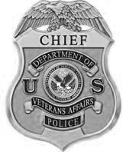

**Shawn J. Kelley**

**Chief of Police**

**Date: May 26, 2015**

Chief Campanello

It was a pleasure meeting with you today and discussing programs that will benefit not only the citizens of Gloucester but Gloucester veterans in particular.  As we forge ahead establishing a mutually supportive relationship, we are especially interested in your program to address the opiate crisis facing numerous communities and our veteran population. The Bedford VA specializes in substance abuse treatment and I feel that working together we can reach out to at risk Gloucester veterans and provide them information on treatment options available to them as veterans.

As discussed our Officers will be meeting with your officers weekly during VA Police site visits to the Gloucester VA CBOC.  VA Police will also provide short briefings during Gloucester Police roll calls on veteran centric topics such as PTSD, TBI, and veterans services and treatment programs.

I look forward to our organizations working cohesively to provide dedicated, professional services to our communities and veterans.

Very Respectfully

**Shawn Kelley**

**Chief Police Service**